**Sprint 1**

|  |  |
| --- | --- |
| Date | 29 October 2022 |
| Team ID | PNT2022TMID14815 |
| Project Name | Project - Personal Assistance for Seniors Who Are Self-Reliant |
| Maximum Marks | 4 Marks |

Login Page:

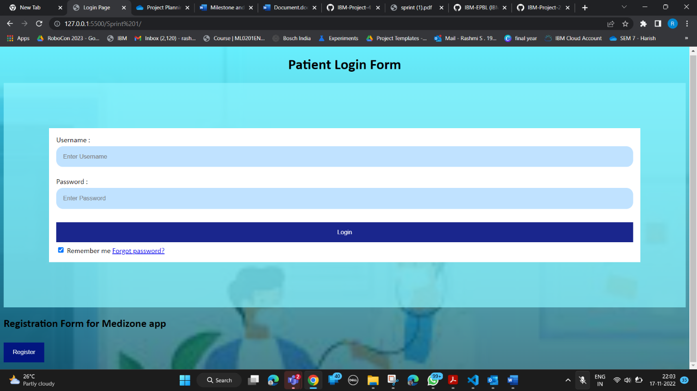

Registration Page:

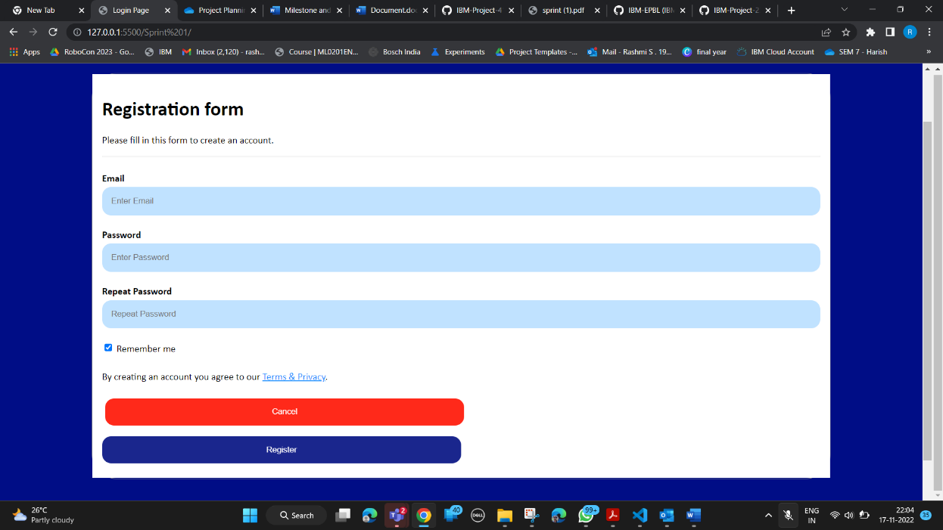

Code:

<!DOCTYPE html>

<html lang="en">

<head>

<meta charset="UTF-8">

<meta http-equiv="X-UA-Compatible" content="IE=edge">

<meta name="viewport" content="width=device-width, initial-scale=1.0">

<link rel ="stylesheet" href ="style.css">

<title>Login Page</title>

</head>

<body>

<center>

<h1> Patient Login Form </h1>

</center>

<form>

<div class="container">

<label>Username : </label>

<input type="text" placeholder="Enter Username" name="username" required>

<label>Password : </label>

<input type="password" placeholder="Enter Password" name="password" required>

<button type="submit">Login</button>

<input type="checkbox" checked="checked"> Remember me

<a href="#"> Forgot password? </a>

</div>

</form>

<h2>Registration Form for Medizone app</h2>

<button onclick="document.getElementById('id01').style.display='block'" style="width:auto;">Register</button>

<div id="id01" class="modal">

<span onclick="document.getElementById('id01').style.display='none'" class="close"

title="Close Modal">&times;</span>

<form class="modal-content" action="/action_page.php">

<div class="container">

<h1>Registration form</h1>

<p>Please fill in this form to create an account.</p>

<hr>

<label for="email"><b>Email</b></label>

<input type="text" placeholder="Enter Email" name="email" required>

<label for="psw"><b>Password</b></label>

<input type="password" placeholder="Enter Password" name="psw" required>

<label for="psw-repeat"><b>Repeat Password</b></label>

<input type="password" placeholder="Repeat Password" name="psw-repeat" required>

<label>

<input type="checkbox" checked="checked" name="remember" style="margin-bottom:15px"> Remember me

</label>

<p>By creating an account you agree to our <a href="#" style="color:dodgerblue">Terms & Privacy</a>.</p>

<div class="clearfix">

<button type="button" onclick="document.getElementById('id01').style.display='none'"

class="cancelbtn">Cancel</button>

<button type="submit" class="signupbtn">Register</button>

</div>

</div>

</form>

</div>

<script>

// Get the modal

var modal = document.getElementById('id01');

// When the user clicks anywhere outside of the modal, close it

window.onclick = function(event) {

if (event.target == modal) {

modal.style.display = "none";

}

}

</script>

</body>

</html><!DOCTYPE html>

<html>